|  |  |  |  |  |  |
| --- | --- | --- | --- | --- | --- |
| Description | Current | Change | Recommended | Allocation | ICR |
| BT Panorama Super | | | | | |
| FI only | $3,333 | $3,333 | $0 | 100.00% | 0.00% |
| BT Panorama Super | $3,333 | $3,333 | $0 |  |  |
| BT Panorama Super | | | | | |
| ABC Share FUND | $10,000 | $10,000 | $0 | 100.00% | 100.00% |
| BT Panorama Super | $10,000 | $10,000 | $0 |  |  |
| BT Panorama Super | | | | | |
| INVESTMENT 8 - MANAGED ACC | $0 | $500,000 | $500,000 | 100.00% | 0.00% |
| BT Panorama Super | $0 | $500,000 | $500,000 |  |  |
| BT Panorama Super | | | | | |
| INVESTMENT 8 - MANAGED ACC | $0 | $450,000 | $450,000 | 100.00% | 0.00% |
| BT Panorama Super | $0 | $450,000 | $450,000 |  |  |
| BT Panorama Super | | | | | |
| Investment number four | $0 | $1,000,000 | $1,000,000 | 95.24% | 0.00% |
| CUSTOM | $0 | $50,000 | $50,000 | 4.76% | 0.00% |
| BT Panorama Super | $0 | $1,050,000 | $1,050,000 |  |  |
| Total | $13,333 | $2,013,333 | $2,000,000 |  |  |

|  |  |  |  |  |  |
| --- | --- | --- | --- | --- | --- |
| Description | Current | Change | Recommended | Allocation | ICR |
| BT Wrap | | | | | |
| INVESTMENT 8 - MANAGED ACC | $999 | $999 | $0 | 100.00% | 0.00% |
| BT Wrap | $999 | $999 | $0 |  |  |
| Total | $999 | $999 | $0 |  |  |

|  |  |  |  |  |  |
| --- | --- | --- | --- | --- | --- |
| Status | Current | Current | Recommended | Recommended | Recommended |
| Description | BT Panorama Super | BT Panorama Super | BT Panorama Super | BT Panorama Super | BT Panorama Super |
| Balance | $3,333 | $10,000 | $500,000 | $450,000 | $1,050,000 |
| One-off Fees Subheader |  |  |  |  |  |
| Ongoing Fees Subheader | | | | | |
| - Sliding Admin Fee | $5.00 (0.15%) | $0.00 (0.00%) | $37.50 (0.01%) | $33.75 (0.01%) | $3.75 (0.00%) |
| - Admin Fee (Flat) | $0.00 (0.00%) | $480.00 (4.80%) | $0.00 (0.00%) | $0.00 (0.00%) | $0.00 (0.00%) |
| - Admin Fee (Floating) | $0.00 (0.00%) | $50.00 (0.50%) | $0.00 (0.00%) | $0.00 (0.00%) | $0.00 (0.00%) |
| - Fund Accounting Fee (Flat) | $22.00 | $200.00 | $0.00 | $0.00 | $0.00 |
| Subtotal | $27.00 | $730.00 | $37.50 | $33.75 | $3.75 |
| Adviser Fee (Flat) | None | None | None | None | None |
| Total | $27.00 (0.81%) | $730.00 (7.30%) | $37.50 (0.01%) | $33.75 (0.01%) | $3.75 (0.00%) |
| Comparative Total | $757.00 | | $75.00 | | |

|  |  |
| --- | --- |
| Status | Current |
| Description | BT Wrap |
| Balance | $999 |
| One-off Fees Subheader |  |
| Ongoing Fees Subheader | |
| - Admin Fee (Floating) | $5.00 (0.50%) |
| - ORR Levy | $49.95 (5.00%) |
| Subtotal | $109.94 |
| Adviser Fee (Flat) | None |
| Total | $109.94 (11.01%) |
| Comparative Total | $109.94 |

|  |  |  |  |  |  |
| --- | --- | --- | --- | --- | --- |
| - Consol Balance | $2,000,000 | $2,000,000 | $2,000,000 | $2,000,000 | $2,000,000 |
| Adviser Fee (Flat) | None | None | None | None | None |

|  |  |
| --- | --- |
| - Consol Balance | $2,000,000 |
| Adviser Fee (Flat) | None |

|  |  |  |  |
| --- | --- | --- | --- |
| Status | Current | Risk Profile | Variance |
| Defensive | | | |
| Cash | 0.70% | 0.00% | 0.70% |
| Australian Fixed Interest | 0% | 49.00% | -49.00% |
| International Fixed Interest | 0% | 0% | 0% |
| Subtotal | 0.70% | 49.00% | -48.30% |
| Growth Subheader | | | |
| Australian Equities | 1.40% | 51.00% | -49.60% |
| International Equities | 0% | 1.00% | -1.00% |
| Australian Listed Property | 0% | 0% | 0% |
| International Listed Property | 0% | 0% | 0% |
| Direct Property | 0% | 0% | 0% |
| Growth Subtotal | 1.40% | 52.00% | -50.60% |
| Alternative Subheader | | | |
| Alternatives | 0% | 0% | 0% |
| Alternative Subtotal | 0% | 0% | 0% |
| Total | 100.00% | 100.00% | 100.00% |

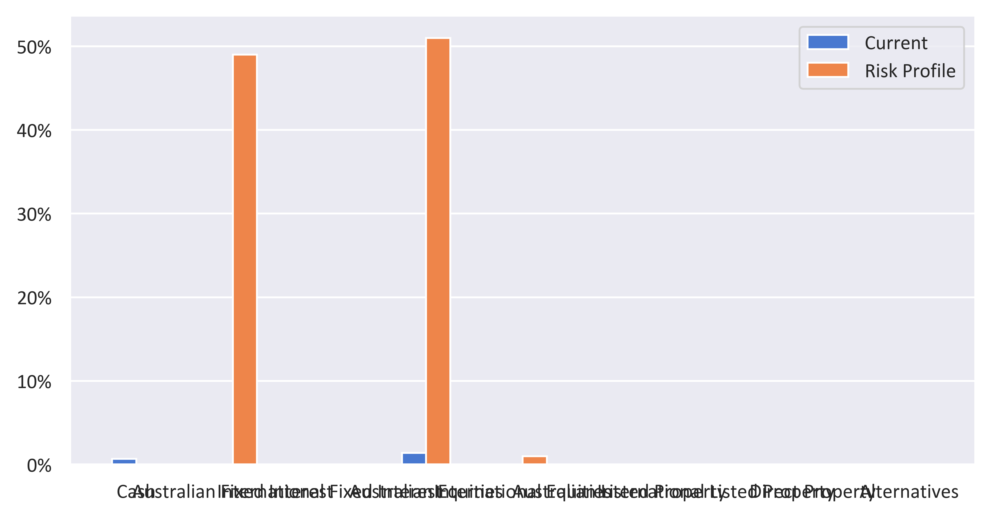

|  |  |  |  |
| --- | --- | --- | --- |
| Status | Recommended | Risk Profile | Variance |
| Defensive | | | |
| Cash | 0% | 0.00% | 0.00% |
| Australian Fixed Interest | 24.75% | 49.00% | -24.25% |
| International Fixed Interest | 24.75% | 0% | 24.75% |
| Subtotal | 49.50% | 49.00% | 0.50% |
| Growth Subheader | | | |
| Australian Equities | 0% | 51.00% | -51.00% |
| International Equities | 0.50% | 1.00% | -0.50% |
| Australian Listed Property | 0% | 0% | 0% |
| International Listed Property | 0% | 0% | 0% |
| Direct Property | 0% | 0% | 0% |
| Growth Subtotal | 0.50% | 52.00% | -51.50% |
| Alternative Subheader | | | |
| Alternatives | 0% | 0% | 0% |
| Alternative Subtotal | 0% | 0% | 0% |
| Total | 100.00% | 100.00% | 100.00% |

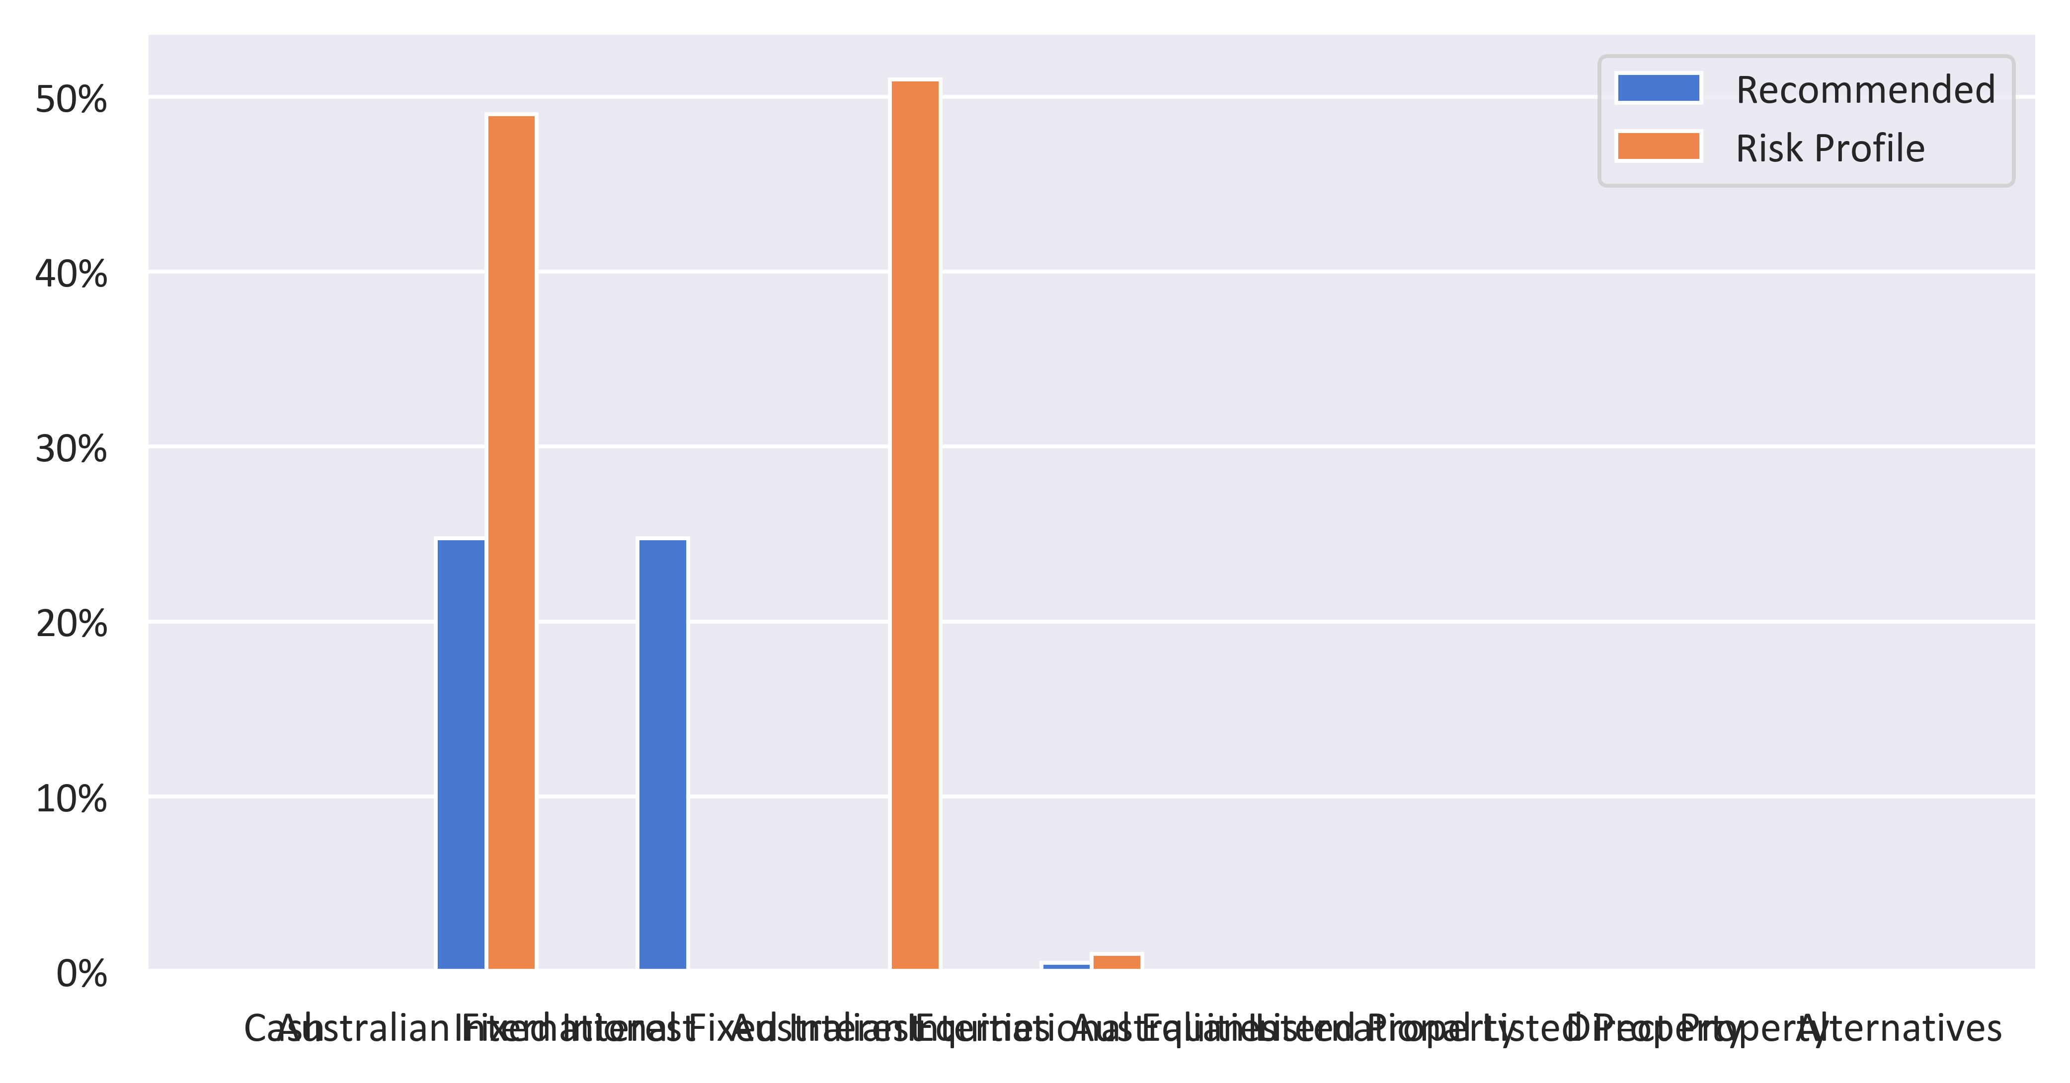

|  |  |  |  |  |
| --- | --- | --- | --- | --- |
| Status | Current | Risk Profile | Recommended | Variance |
| Defensive | | | | |
| Cash | 0.70% | 0.00% | 0% | 0.00% |
| Australian Fixed Interest | 0% | 49.00% | 24.75% | -24.25% |
| International Fixed Interest | 0% | 0% | 24.75% | 24.75% |
| Subtotal | 0.70% | 49.00% | 49.50% | 0.50% |
| Growth Subheader | | | | |
| Australian Equities | 1.40% | 51.00% | 0% | -51.00% |
| International Equities | 0% | 1.00% | 0.50% | -0.50% |
| Australian Listed Property | 0% | 0% | 0% | 0% |
| International Listed Property | 0% | 0% | 0% | 0% |
| Direct Property | 0% | 0% | 0% | 0% |
| Growth Subtotal | 1.40% | 52.00% | 0.50% | -51.50% |
| Alternative Subheader | | | | |
| Alternatives | 0% | 0% | 0% | 0% |
| Alternative Subtotal | 0% | 0% | 0% | 0% |
| Total | 100.00% | 100.00% | 100.00% | 0.00% |

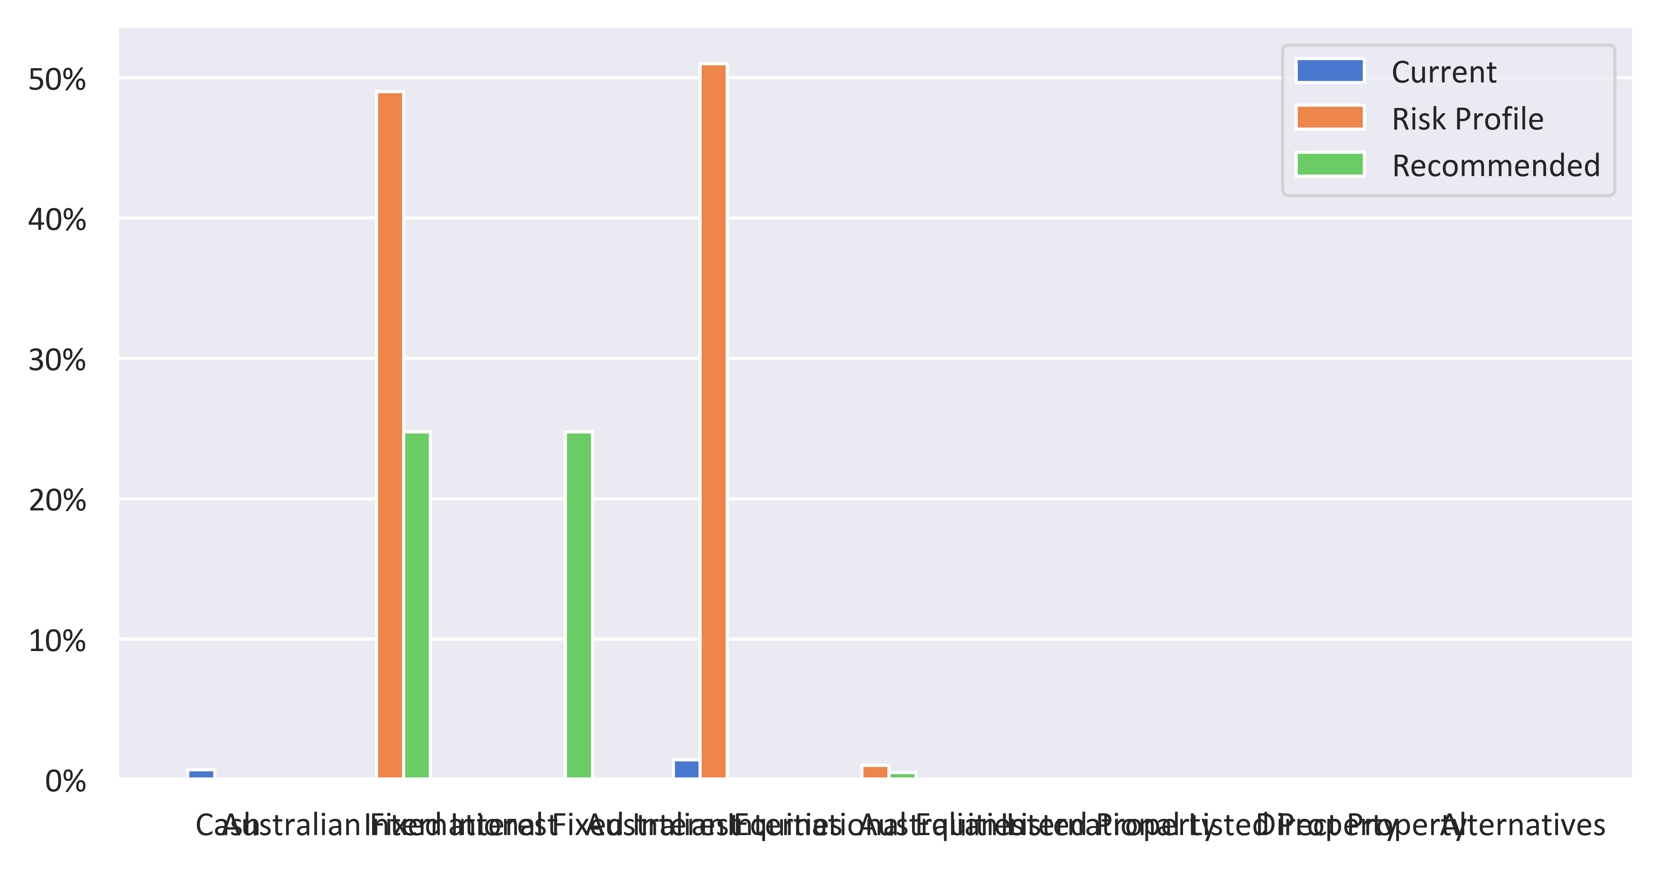

|  |  |  |  |
| --- | --- | --- | --- |
| Status | Current | Recommended | Variance |
| Defensive | | | |
| Cash | 0.70% | 0% | -0.70% |
| Australian Fixed Interest | 0% | 24.75% | 24.75% |
| International Fixed Interest | 0% | 24.75% | 24.75% |
| Subtotal | 0.70% | 49.50% | 48.80% |
| Growth Subheader | | | |
| Australian Equities | 1.40% | 0% | -1.40% |
| International Equities | 0% | 0.50% | 0.50% |
| Australian Listed Property | 0% | 0% | 0% |
| International Listed Property | 0% | 0% | 0% |
| Direct Property | 0% | 0% | 0% |
| Growth Subtotal | 1.40% | 0.50% | -0.90% |
| Alternative Subheader | | | |
| Alternatives | 0% | 0% | 0% |
| Alternative Subtotal | 0% | 0% | 0% |
| Total | 100.00% | 100.00% | 100.00% |

